SIMATS ENGINEERING
ASSESSMENT TOOL 3 – Assignment 2

COURSE NAME: STATISTICS WITH R PROGRAMMING COURSE CODE: ITA04

COURSE OUTCOME COVERED

CO3: Construct and manipulate data frames using reshaping, merging, and file I/O operations in R to prepare structured datasets for analysis. (BL3, BL5)

Assessment Tool Weightage: 20%

QUESTIONS: 5 Total Marks: 100

Annexure

Assignment 2

Code of Conduct:

I Varsha.M/1924260282 (Name / Reg No) certify that this submission is my original work and that I have adhered to the guidelines specified for this assessment.
I understand that any violation of academic integrity rules will result in disciplinary action.

Signature of the student: 

Assignment 2:
- Generate 5 Questions for your Capstone Project module
- Apply the formulae and use the relevant graph to visualize it
- Upload the file in Github link
- Save the 5 Questions and Gihub link in the Excell sheet

Module 4-Population Growth Prediction and Future Forecasting

1. Using historical population data, predict the population for future years using linear regression and visualize the population growth with a line chart.
Formula
Linear Regression:
$$y=a+bx$$
Where:
- $y$= Predicted population
- $x$= Year
- $a$= Intercept
- $b$= Slope
Code
# Historical population data
year <- 2020:2024
population <- c(100000, 105000, 110000, 115000, 120000)

# Create a linear regression model
model <- lm(population ~ year)

# Predict future population
future_year <- 2025:2027
predicted <- predict(model, data.frame(year = future_year))

# Display predictions
print(data.frame(Year = future_year,
Predicted_Population = round(predicted)))

# Line chart
plot(year, population,
type = "o",
col = "blue",
xlim = c(2020, 2027),
ylim = c(100000, 135000),
xlab = "Year",
ylab = "Population",
main = "Population Growth Prediction")

lines(future_year, predicted,
type = "o",
col = "red",
lty = 2)

legend("topleft",
legend = c("Historical", "Predicted"),
col = c("blue", "red"),
lty = c(1, 2),
pch = 1)
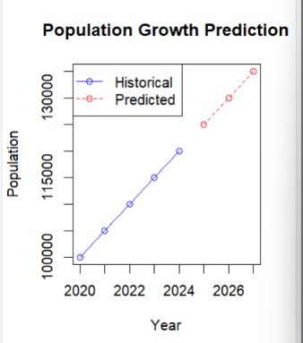
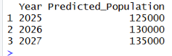
2. Calculate the annual population growth rate and display the growth using a bar chart.
Formula
$$\text{Growth Rate}=\frac{P_{2}-P_{1}}{P_{1}}×100$$
Where:
- $P_{1}$= Previous year's population
- $P_{2}$= Current year's population
Code
# Population data
year <- 2021:2025
population <- c(100000, 105000, 110000, 118000, 125000)

# Calculate growth rate
growth_rate <- diff(population) /
head(population, -1) * 100

# Display results
print(data.frame(
Year = year[-1],
Growth_Rate = round(growth_rate, 2)
))

# Bar chart
barplot(growth_rate,
names.arg = year[-1],
col = "skyblue",
xlab = "Year",
ylab = "Growth Rate (%)",
main = "Annual Population Growth Rate")
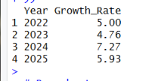
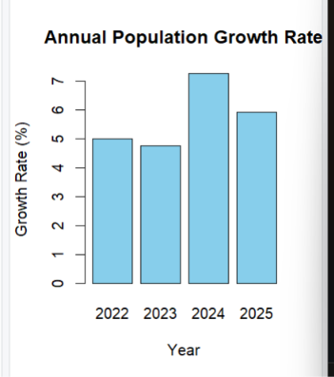
3. The populations of five cities are Chennai (1000000), Coimbatore (600000), Madurai (400000), Salem (300000), and Trichy (250000). Write an R program to calculate the percentage contribution of each city's population and display the distribution using a pie chart.
Formula
Population Percentage=Total Population/City Population​×100
Code
# City names
city <- c("Chennai", "Coimbatore", "Madurai",
"Salem", "Trichy")

# Population data
population <- c(1000000, 600000, 400000, 300000, 250000)

# Calculate percentages
percentage <- population / sum(population) * 100

# Display results
print(data.frame(
City = city,
Population = population,
Percentage = round(percentage, 2)
))

# Pie chart
pie(population,
labels = paste(city, round(percentage, 1), "%"),
col = rainbow(5),
main = "Population Distribution Across Cities")
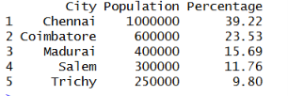
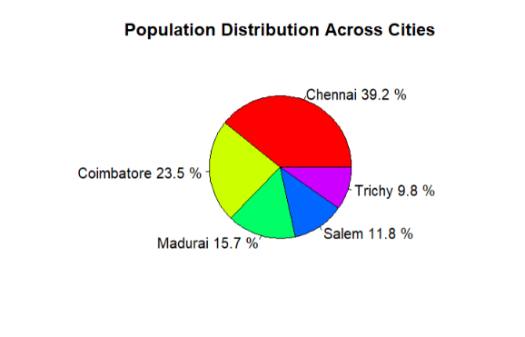
4. A town recorded its population as 90000 in 2019, 95000 in 2020, 100000 in 2021, 108000 in 2022, 115000 in 2023, and 120000 in 2024. Write an R program to calculate the correlation coefficient between year and population and represent the relationship using a scatter plot.
Formula
Pearson Correlation Coefficient:
$$r=\frac{\sum{(}\left.x-\overline{x}\right)\left(y-\overline{y}\right)}{\sqrt{\sum{(}\left.x-\overline{x}{\left.)\right.}^{2}\sum{(}\left.y-\overline{y}{\left.)\right.}^{2}\right.\right.}}$$
Where:
- $x$= Year
- $y$= Population
- $r$= Correlation coefficient
# Data
year <- 2019:2024
population <- c(90000, 95000, 100000, 108000, 115000, 120000)

# Calculate correlation
correlation <- cor(year, population)

# Display result
print(paste("Correlation Coefficient:",
round(correlation, 3)))

# Scatter plot
plot(year, population,
pch = 19,
col = "darkgreen",
xlab = "Year",
ylab = "Population",
main = "Year vs Population")

# Add trend line
abline(lm(population ~ year),
col = "red",
lwd = 2)
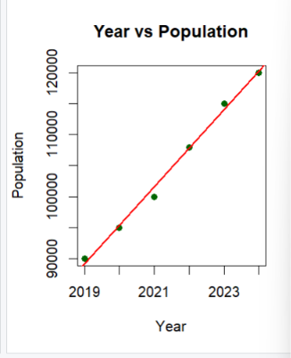
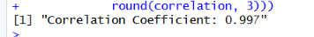
5. The population of a town was recorded as 80000 in 2020, 85000 in 2021, 92000 in 2022, 98000 in 2023, 107000 in 2024, and 115000 in 2025. Write an R program to calculate the annual population increase, find the average annual increase, and represent the distribution of population increases using a histogram.
Formula
Annual Population Increase:
$$G=P_{\text{current}}-P_{\text{previous}}$$
Average Annual Increase:
$$\overline{G}=\frac{\sum{G}}{n}$$
Where:
- $G$= Annual population increase
- $\overline{G}$= Average annual increase
- $n$= Number of annual increases
Code
# Population data
year <- 2020:2025
population <- c(80000, 85000, 92000, 98000, 107000, 115000)

# Calculate annual increase
growth <- diff(population)

# Calculate average increase
average_growth <- mean(growth)

# Display results
print(data.frame(
Year = year[-1],
Annual_Increase = growth
))

print(paste("Average Annual Increase:",
round(average_growth)))

# Histogram
hist(growth,
breaks = 5,
col = "orange",
xlab = "Annual Population Increase",
ylab = "Frequency",
main = "Distribution of Population Growth")
